Virtualization:
Virtualization is a technology that allows to create virtual, simulated environments from a single, physical machine. For example: creating multiple VM’s in single host machine.

Virtualization uses a hypervisor, an application that allows to creates a VM’s or abstraction layer that emulates the available hardware resources including the RAM, CPU, USB ports, NICS, and many more. This makes it possible for guests or virtual machines to use them.

Virtual machines are virtualized OS which are isolated and run independently of the host system. They emulate the hardware components of the host machine like CPU, RAM, network interfaces, and storage etc.
Since virtual machines uses the same resources used by the host machine, this may result in high resource overhead which can impact performance.
VMs are much larger in comparision to containers as they contain an entire operating system which are typically in GB. Hence, high resource utilization. Containers are much smaller and can take as low as a few megabytes of storage.

Docker:
Docker is a containerization platform that simplifies the deployment and management of applications. It allows applications to be packaged with their dependencies into containers, which can be run consistently across different environments. Docker provides isolation, scalability, and portability, making it an essential tool in DevOps.

Docker vs Hypervisor:
Hypervisors virtualize hardware resources and allow multiple operating systems to run simultaneously on a single physical host

Docker, provides containerization, which allows for lightweight and isolated execution of applications without the need for full virtual machines.

Docker containers share the host system’s kernel, making them more efficient and lightweight compared to virtual machines which has its own kernel

Key difference between containers and virtual machines is that virtual machines virtualizes an entire machine down to the hardware layers and containers only virtualizes software layers above the operating system level. Hence, VM’s are hardware level virtualization where as containers are OS-level virtualization (also known as containerization

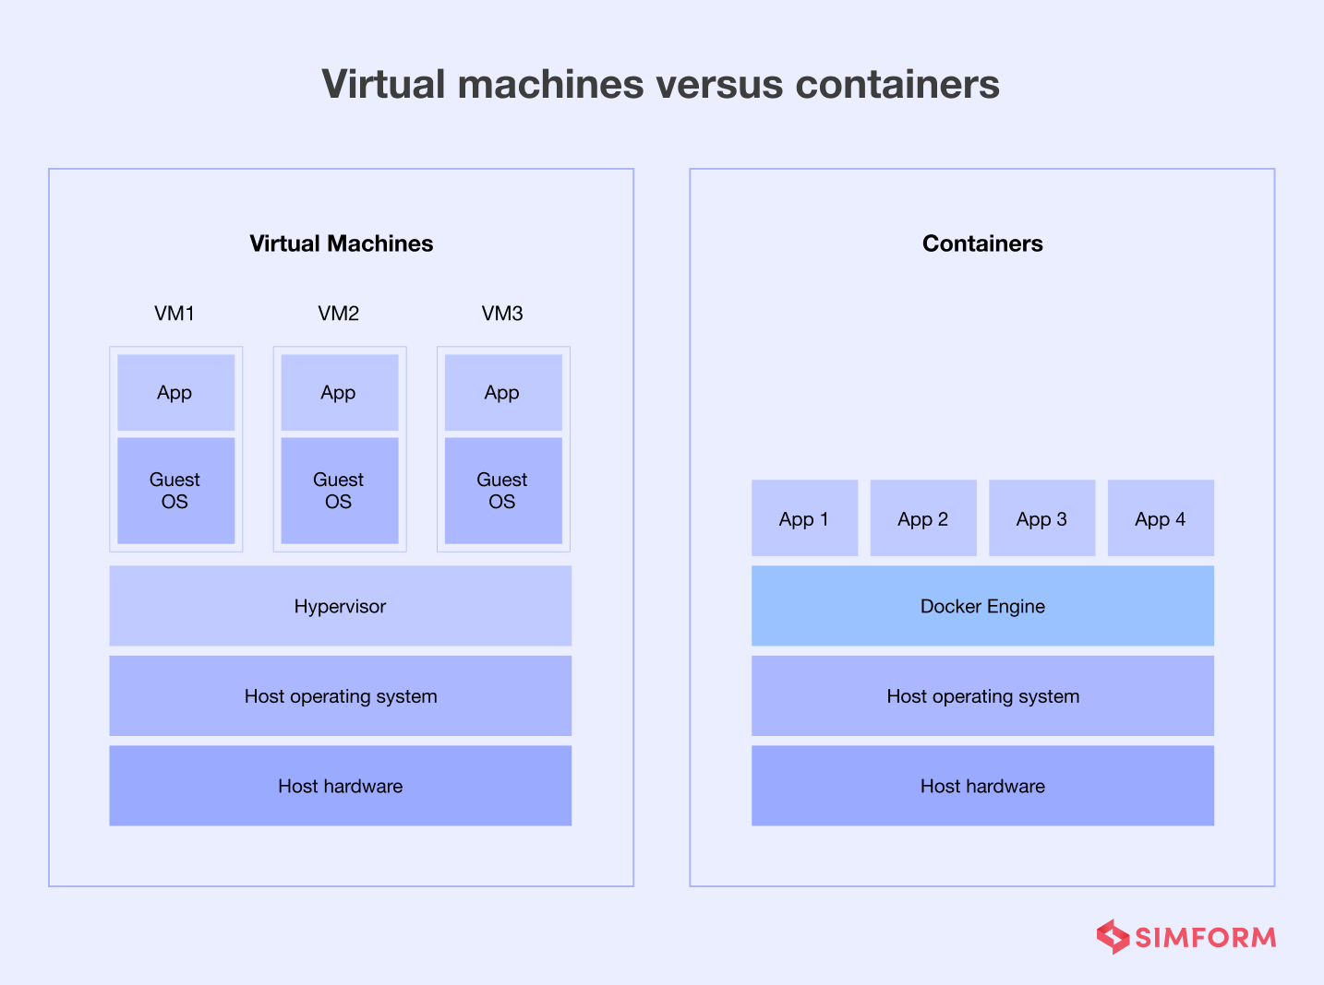

Components of Docker / Architecture:

Docker Daemon: The Docker daemon is the background service responsible for building, running, and managing Docker containers.

Docker Client: The Docker client is a command-line interface (CLI) tool used to interact with the Docker daemon. It sends commands to the daemon, which then executes them.

Docker images: Lightweight, executable software packages containing everything needed to run an application.

Docker Containers: Runtime instances of Docker images, providing isolation and portability.

Dockerfile:
Configures and builds custom Docker image by specifying the steps for the build process.

Docker Registry: Centralized repository for storing and sharing Docker images.

Docker Compose: Orchestrates multiple containers, defining their configuration in a YAML file.

Why Docker?
Docker provides a consistent environment for software applications, making it easier to develop, deploy, and scale applications across different environments.
Docker enables the isolation of applications and their dependencies, ensuring that they run consistently regardless of the underlying infrastructure.
Docker simplifies the process of packaging applications and their dependencies into portable and lightweight containers, reducing deployment time and improving scalability.

##To remove all stopped containers
sudo docker container prune -f
##To monitor cpu usage of containers
docker stats --no-stream
OR
docker stats --all

##To check storage related info
docker system df -v

Docker Volumes and Bind Mounts:
Docker Volumes: Managed by Docker, stored in a location controlled by Docker, and preferred for persisting data.
Bind Mounts: Directly mounts a directory or file from the host filesystem to the container, providing direct access to the host’s files.
# Volume
docker run -v myvolume:/app/data my-java-app
# Bind Mount
docker run -v /path/on/host:/app/data my-java-app

sudo docker run -d --name bankapp-mysql -e MYSQL_ROOT_PASSWORD=Test@123 -e MYSQL_DATABASE=BankDB -p 3306:3306 mysql:latest

sudo docker run -d --name bankapp -p 8080:8080 --link bankapp-mysql:mysql -e SPRING_DATASOURCE_URL="jdbc:mysql://mysql:3306/BankDB?useSSL=false&allowPublicKeyRetrieval=true&serverTimezone=UTC" -e SPRING_DATASOURCE_USERNAME=root -e SPRING_DATASOURCE_PASSWORD=Test@123 bankapp

